For both Procedure 1 and 2:

- Follow this link to the Population Ecology presentation on Google Earth.
NOTE: If you have trouble accessing or using the Google Earth presentation, follow the directions found in the “Alternate Procedure: READ if you have trouble with Google Earth” subsection of the module.

- Click on the “Present” button - this will take you to the Population Ecology presentation, which will walk you through all the steps you need to complete both of these procedures.
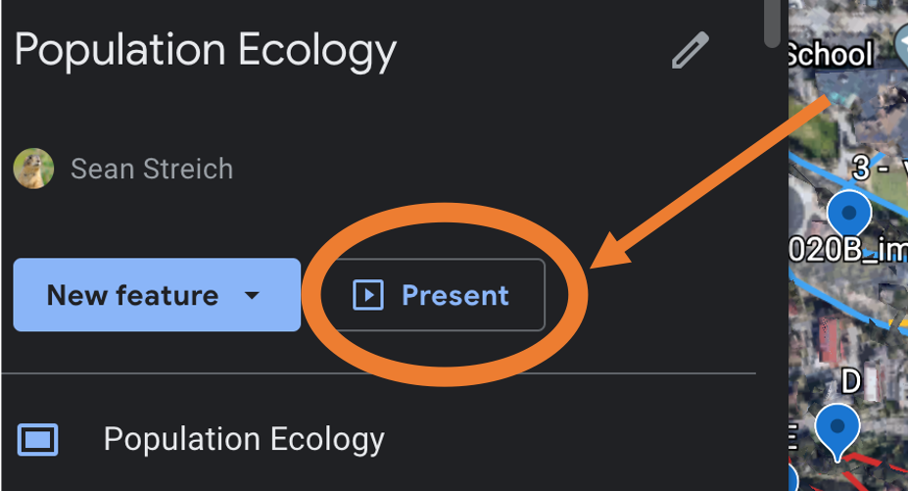

Once you are in the presentation, you can use the “>” and “<” links, in the lower left corner, to scroll forwards and backwards through the slides. We recommend following all the slides, in order, for best results.
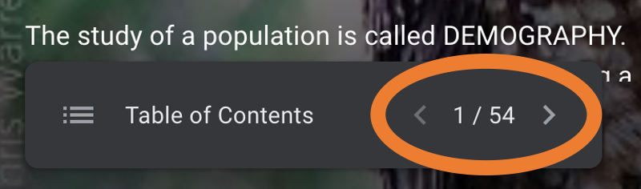

Procedure 1: Telemetry AND Procedure 1 - update: GPS
The online presentation will provide information and links to each of these sections. This is designed to go with Procedure 1 in your lab manual (pp. 165-166).

Note: the lab manual focuses on telemetry as a tracking method. One advantage of using this online format is that you can explore a more state-of-the art (and more expensive!) method for tracking animals: GPS tracking. See Procedure 1 - update for more details.

In this section, you will find and identify two GPS-tracked owls. Use the ID guide in your manual (pp. 169-170) to correctly identify all the spotted owls you find, and mark them in your datasheet (located on p. 171).

Explore Google Earth on your own. There are many ways to utilize this resource. When you are exploring look in the bottom right. Here you can find information for location coordinates and elevation. For example, you can look at the world in 3D models and street view.
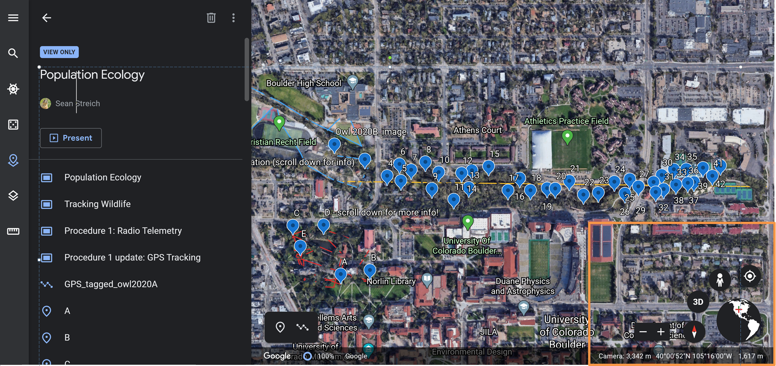

Procedure 2: Owl study transect
This section is designed to go with Procedure 2 in your manual (pp. 166-170).

In this lab, you would learn to use binoculars to help identify owls in trees. Follow this link for a great video on binocular use.

In the same Google Earth presentation, you will come to a study transect with photographs of Spotted Owls. Some are banded, some are not banded. Some are dead; dead owls will either be on the ground, with tears to indicate death, or in the talons of a predator like the Great Horned Owl.

Identify all the owls you see, INCLUDING the dead owls and owl offspring, using the ID guide on pp 169-170 of your manual. Record the information for each Spotted Owl in the datasheet on p. 171: each Spotted Owl gets its own line including offspring which are in the 0-1 age class. Scroll down for examples of owl ID and datasheet recording.

Make sure you go through the entire transect; you should find 42 locations total, each with 1 or more owls.

DO NOT record the Great Horned Owls! They are not part of the Spotted Owl population. Take your time and be accurate. You will use this data to complete the rest of the lab.

Note that you can click on an owl image to enlarge it for easier viewing. Images that have “<” and “>” symbols have more than one image for that viewing point.

Example 1: Owl with offspring
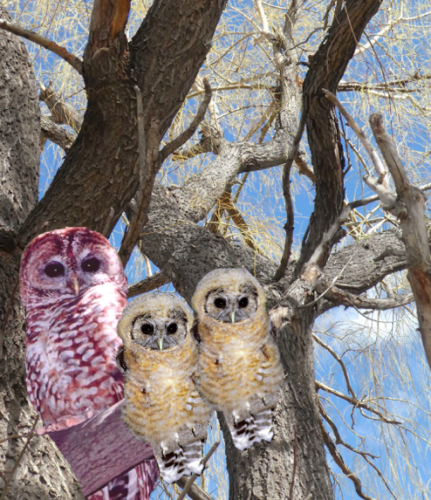
For this example, your entry for table 12.3 would look like this. Remember, each Spotted Owl gets its own line in the table.

Sex | Alive or Dead | Banded (+ or -) | Age Class | # of Fledglings
Female | Alive | - | 2-8 | 2
Male | Alive | - | 0-1
Male | Alive | - | 0-1

Notice how all three individuals are listed in the first column, followed by the information related specifically to that individual. Only the adult female gets marked as having any fledglings. In this example, the number of fledglings would be two because there are two young owls nearby.

Example 2: Banded Owl
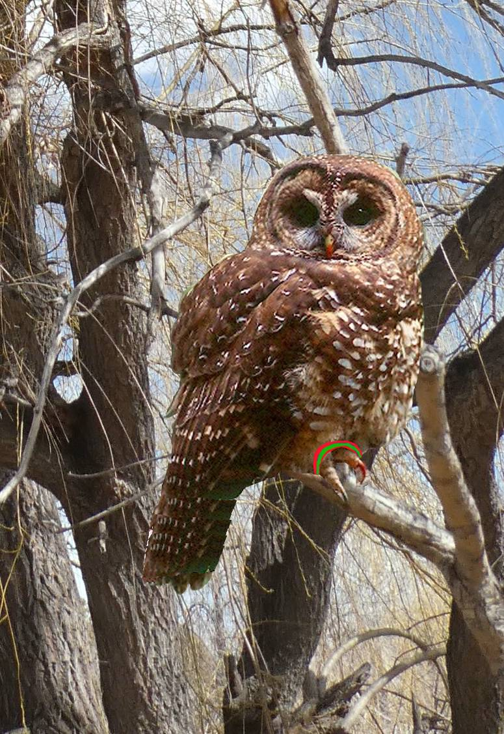

For this owl, notice that there is a band on its leg. The band color isn’t important, but make sure that you use a “+” in your data table to indicate that it is banded.

Sex | Alive or Dead | Banded (+ or -) | Age Class | # of Fledglings
Female | Alive | + | 1-2

Example 3: Dead owls
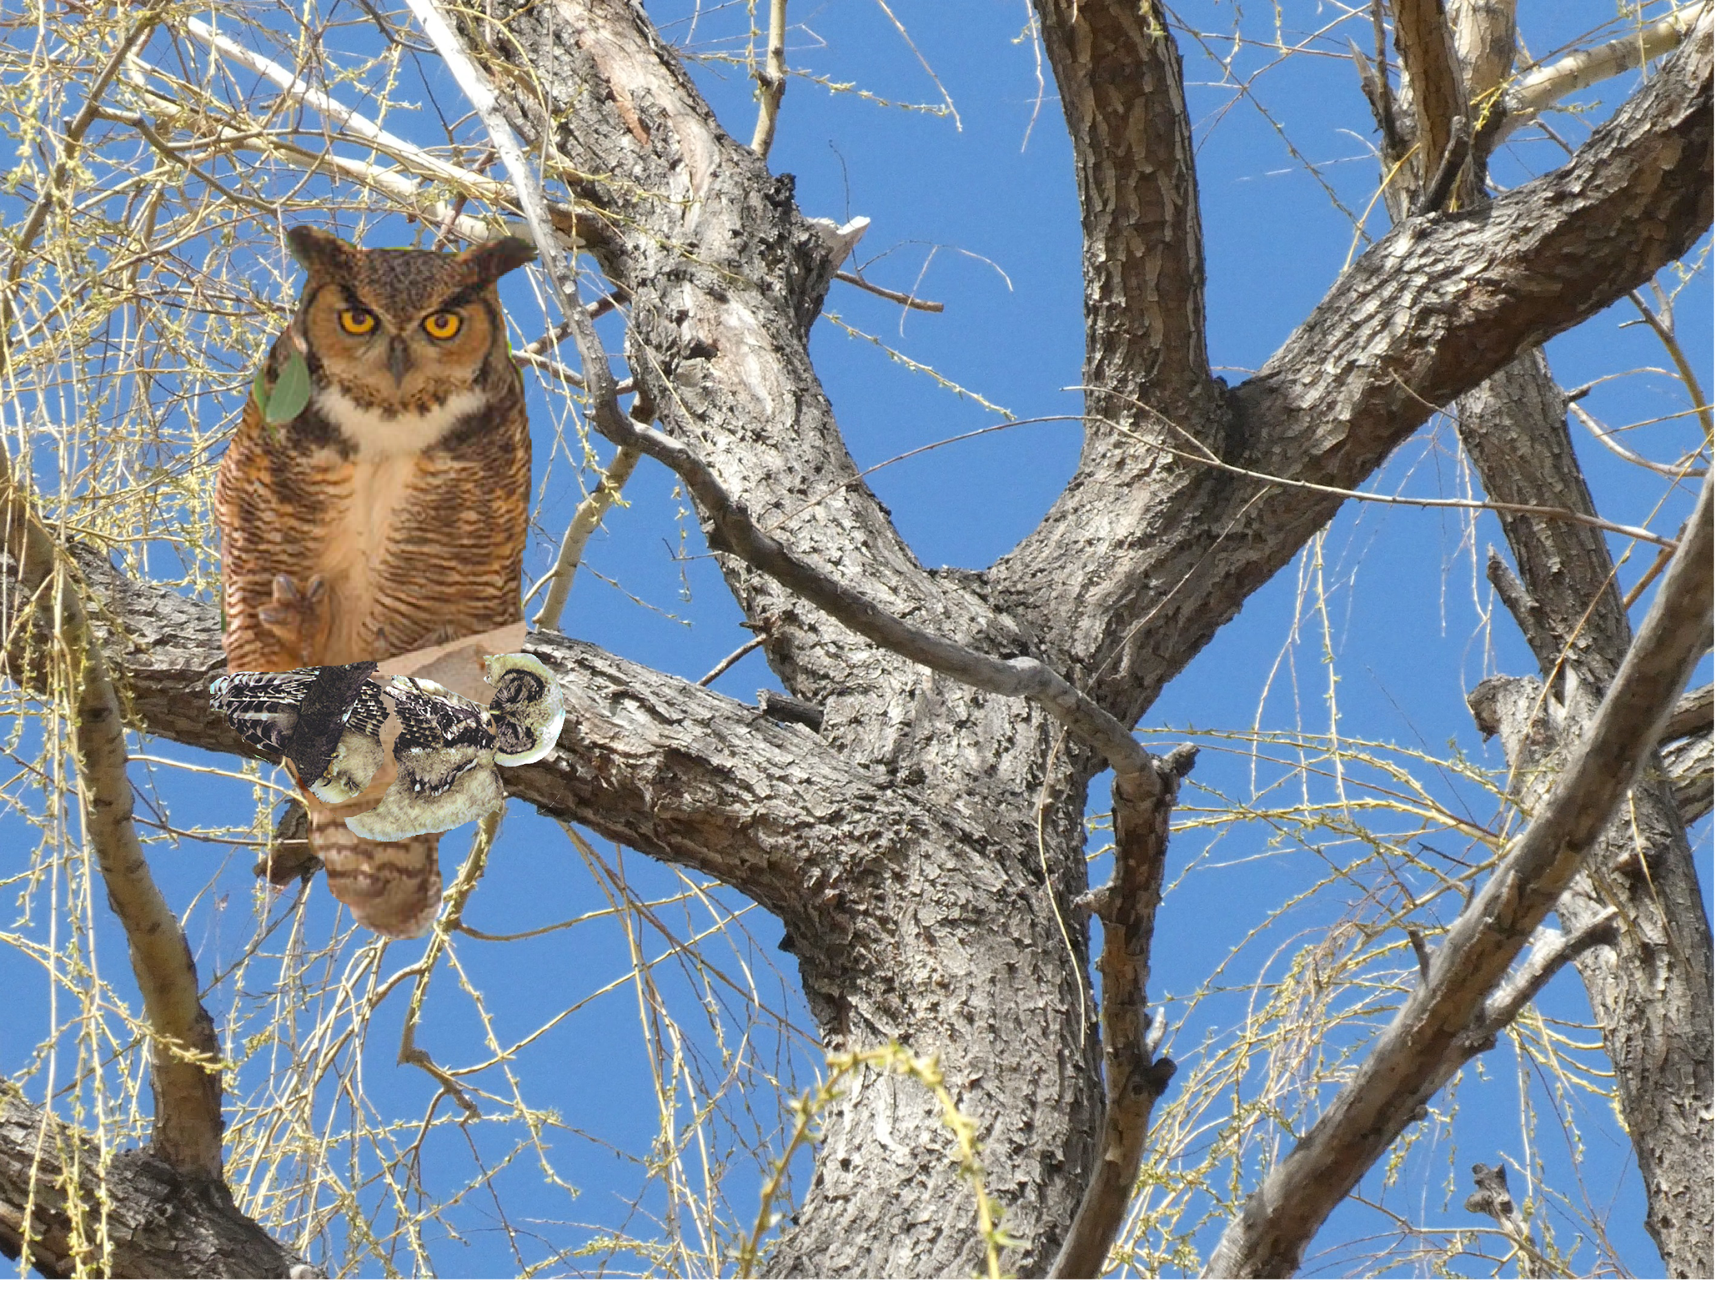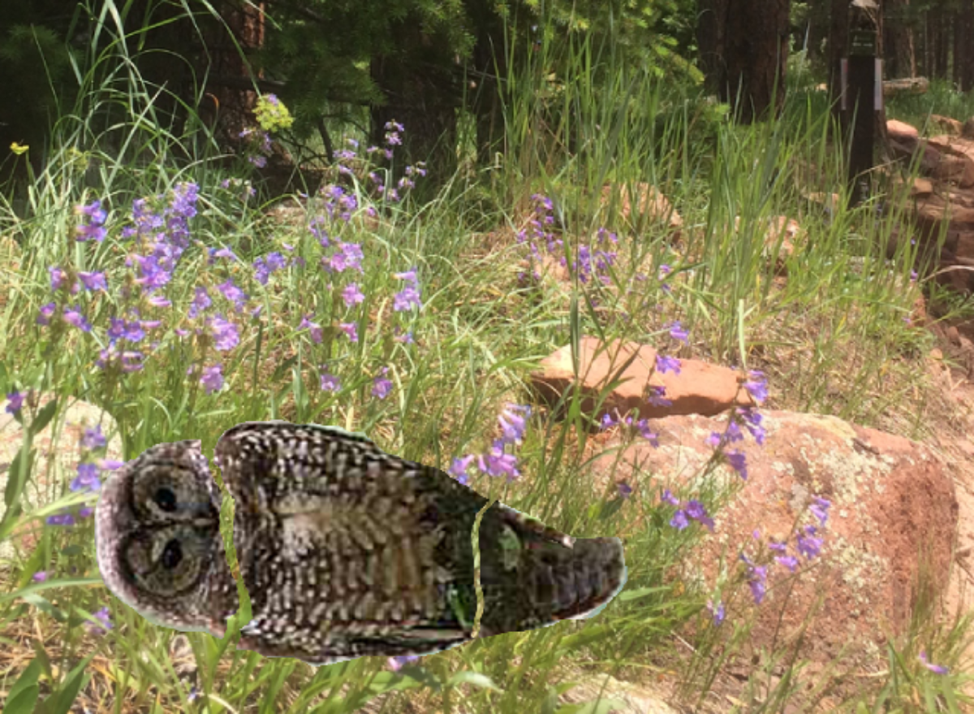
Note: You may see dead owls in the talons of a Great Horned Owl, or on the ground with a few tears to indicate death.

Sex | Alive or Dead | Banded (+ or -) | Age Class | # of Fledglings
Female | Dead | - | 0-1
Female | Dead | - | 8-13

Remember that only the Spotted Owls need to be recorded on the table. It is unnecessary to record information related to the Great Horned Owl (the large owl in the first photo)

